Fofa：app="MAiPU-无线控制器"
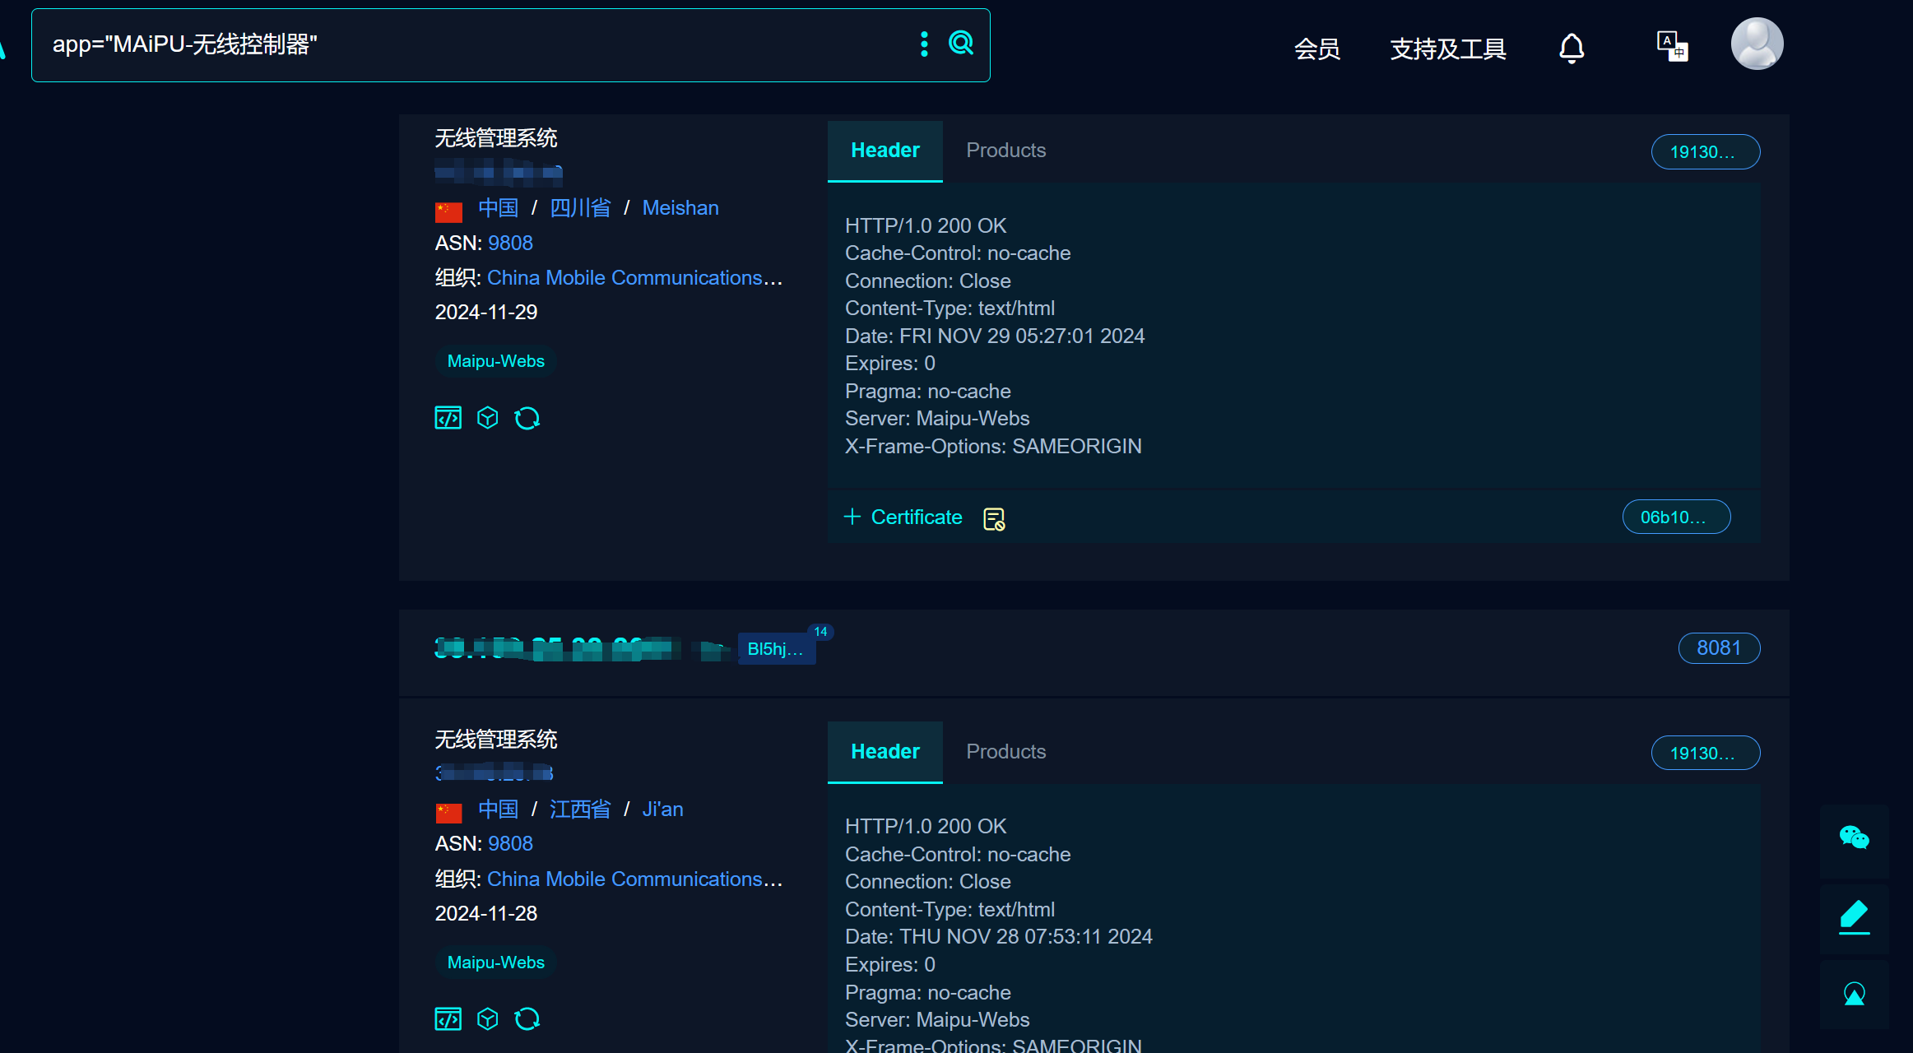

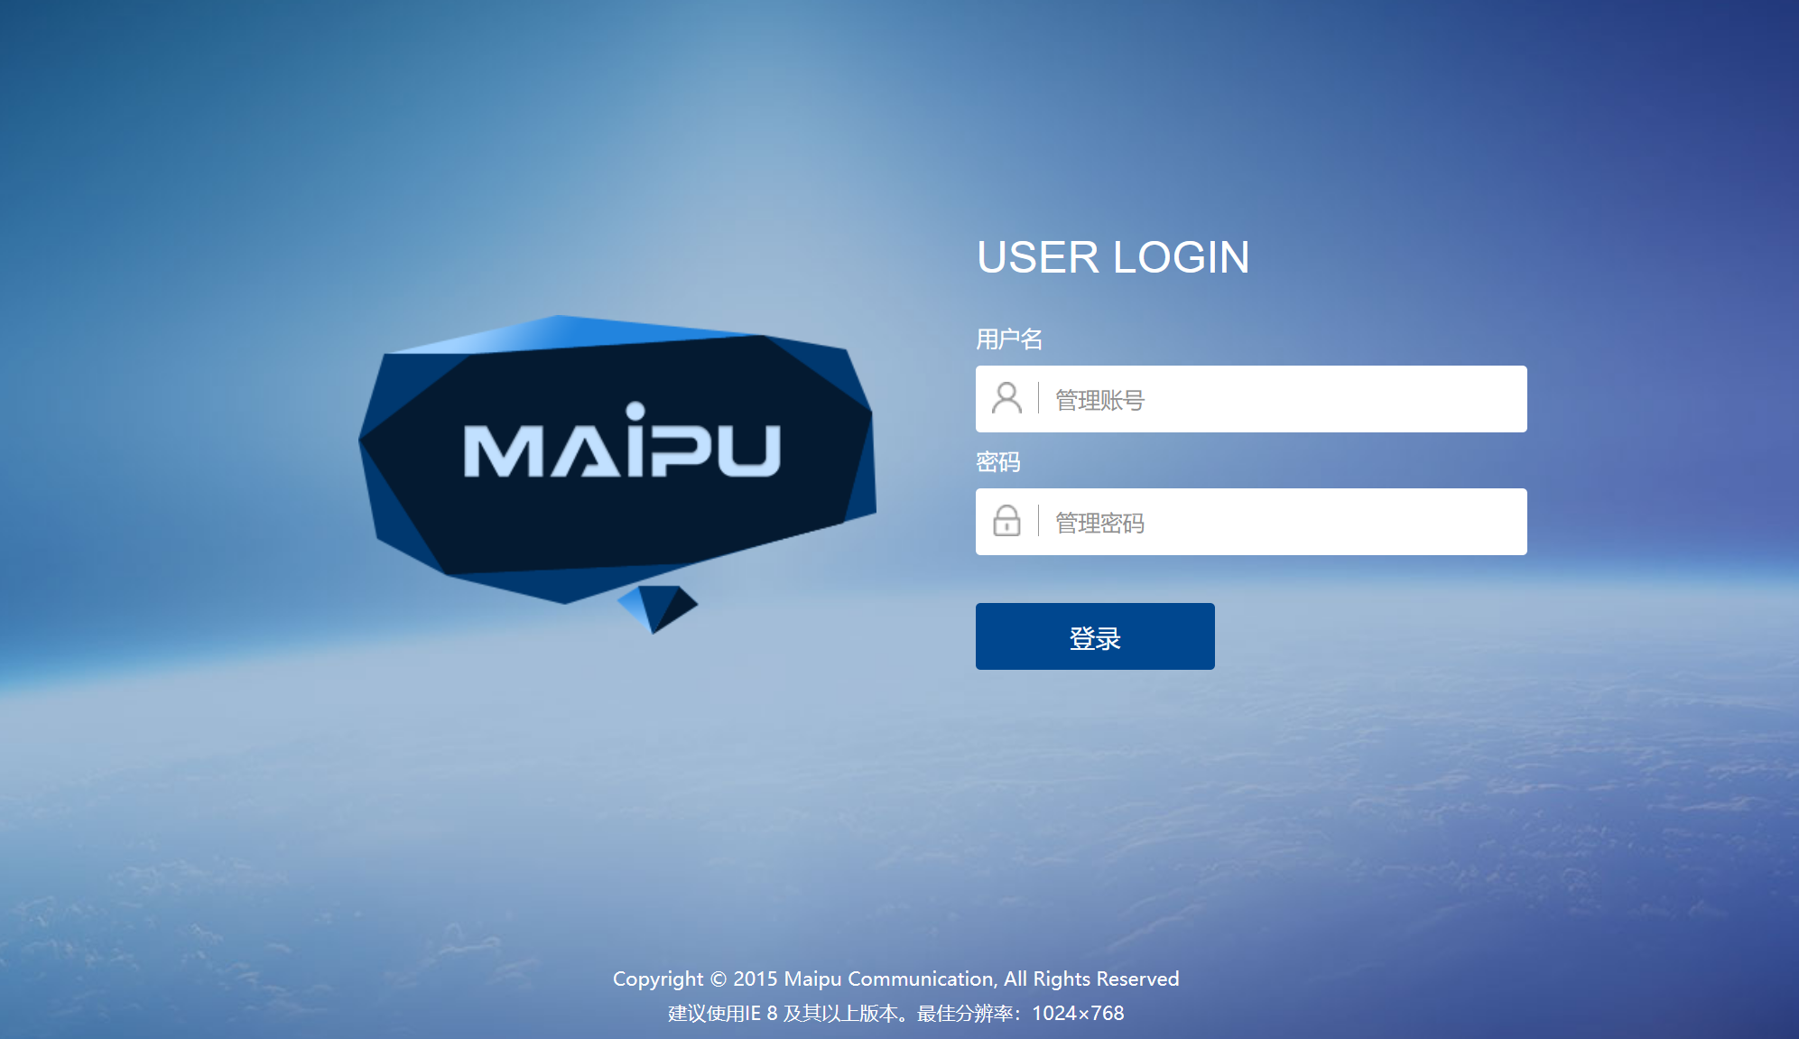
Version：software version>V6

Unauthorized access to an interface allows you to read any system file
through this interface：/form/acLicenseOutputByHttp
/form/exportConfigByHttp
